Last Updated: 08/18/2021
This QRG outlines the process of processing an employee’s Demotion – No Transfer with or without Pay Decrease in SuccessFactors.
Contents
What is a Demotion – No Transfer with or without a Pay Decrease? 1
Applicable Policies 1
Demotion – No Transfer with a Pay Decrease Process 2
Access SuccessFactors 2
Searching for an Employee 3
Taking Action 3
Processing a Demotion – No Transfer with or without a Pay Decrease 4
Processing a Demotion – No Transfer With Pay Decrease 5

Access SuccessFactors
Visit OneCampus and select Employee Launchpad or from the Employee Self-Service web page click SuccessFactors  Log in using Purdue Career Account ID and Password. | https://one.purdue.edu/  https://www.purdue.edu/hr/global/pgnew.php  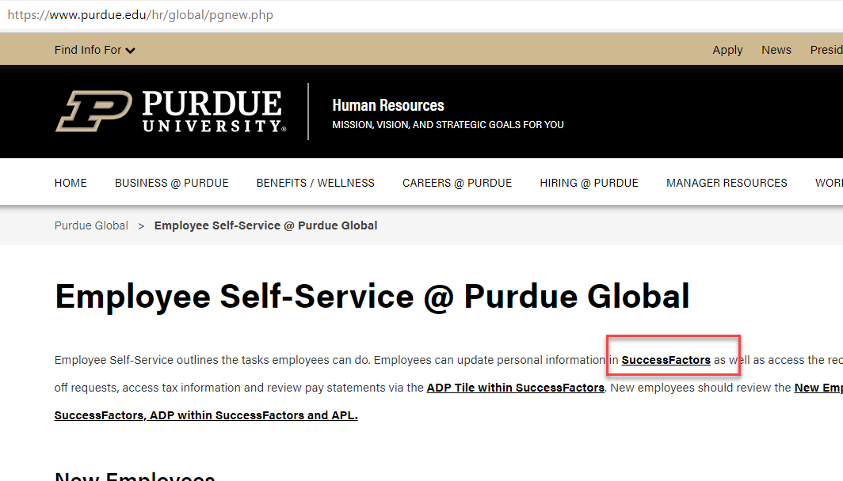
From the SuccessFactors home page, type the name of the employee in the Search field on the navigation bar.

Searching for an Employee
As the employee’s name is being typed, multiple matches may be displayed.  Scroll down to the correct employee’s name and click to select. | 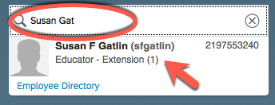
This will display the employee’s Employee File. | 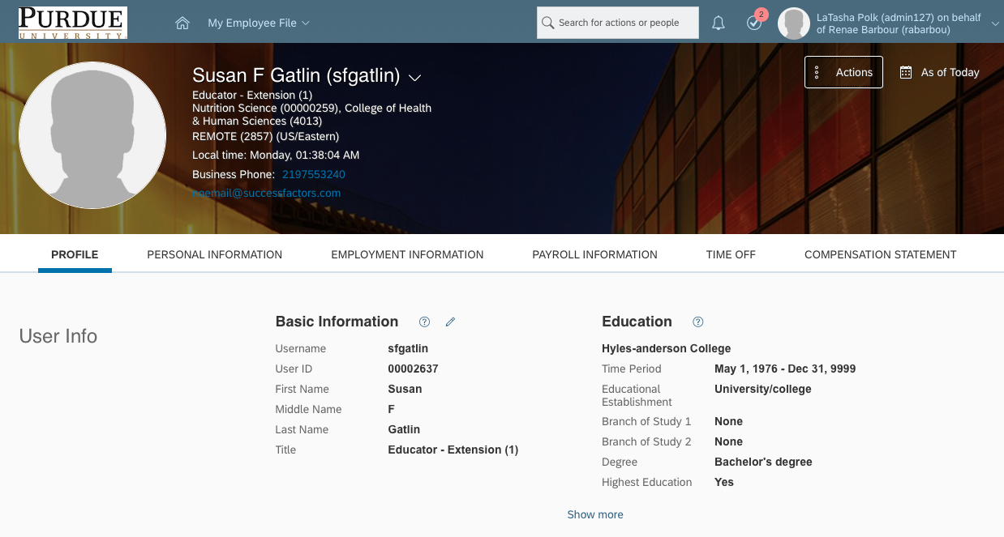

Taking Action
Click on Actions to display drop down menu and select Change Job and Compensation Info. | 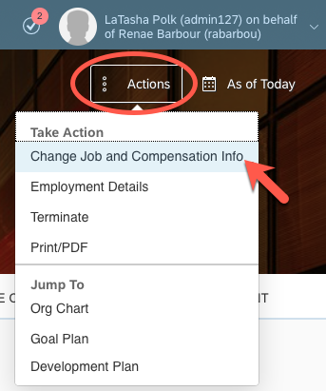
The Change Job and Compensation Info box is displayed.  Check the boxes next to Job Information and Compensation Information. | 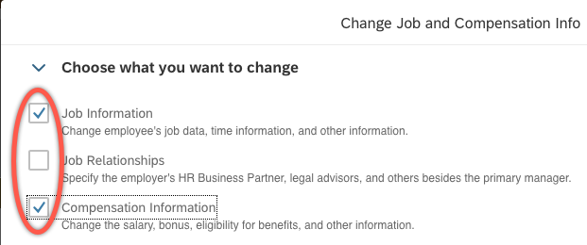

Processing a Demotion – No Transfer with or without a Pay Decrease
Select the date the effective date by clicking the Calendar icon or by manually entering the date (MMDDYY). | 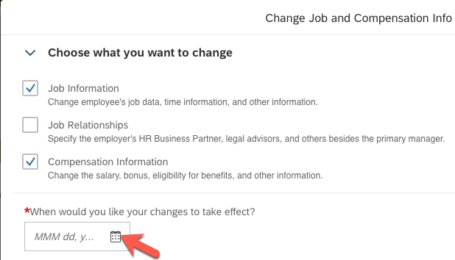
Scroll to the Job Information header.  Change the Job Classification and Position Title in that order.  Upon changing the Job Classification, other information will automatically update (i.e. Employee Class, Job Title, etc.  If you are changing a position from salaried to hourly or from hourly to salaried, you will need to select the appropriate Employment Type.  It’s important to note that you should never change the Position under the Position Information section (section that is two sections before the Job section). That moves the employee to a completely different position. For the No Transfer actions, we do not want the employee’s record to be a change in positions, only Jobs. The only position related item that should change is the Position Title in the Job Section. | 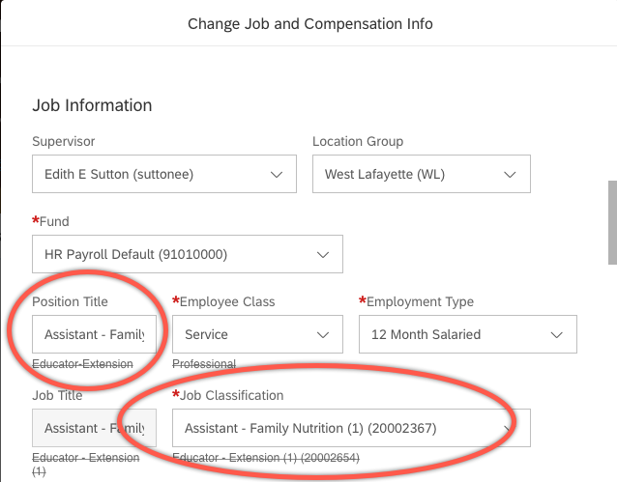

Processing a Demotion – No Transfer With Pay Decrease
Skip this step if a Pay Decrease is not needed
If a pay decrease is associated with the demotion, scroll down to the Compensation section.
Change the Amount if a new bi-weekly salary or hourly rate is needed.
If you are changing from salaried to hourly, make sure the Pay Component is changed to Hourly (1005) and type the hourly rate into the Amount box. This change will update the frequency.
If you are changing from hourly to salaried, make sure the Pay Component is changed to A-Base Salary (1000) and type the bi-weekly rate into the Amount box.
Click Save.
A pop-up box may appear as a warning if you changed the FTE or the Employment Type. If this occurs, you will need to reselect the Pay Component (click on Correct and reselect the Pay Component). If you did NOT change these fields, click Proceed.
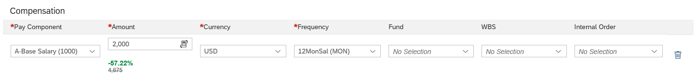
The confirmation box appears.  - Make sure the reason listed is No Transfer with or without Pay Decrease for XXXX.  - Click on Show workflow participants to view who is required to approve the request.  - Click Confirm to initiate the workflow.  Note: Once complete, a notification will be sent to the approver(s). | 